R1 (Router 1) configuration:

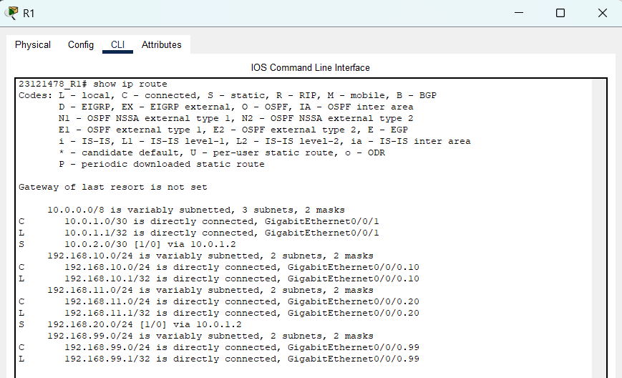

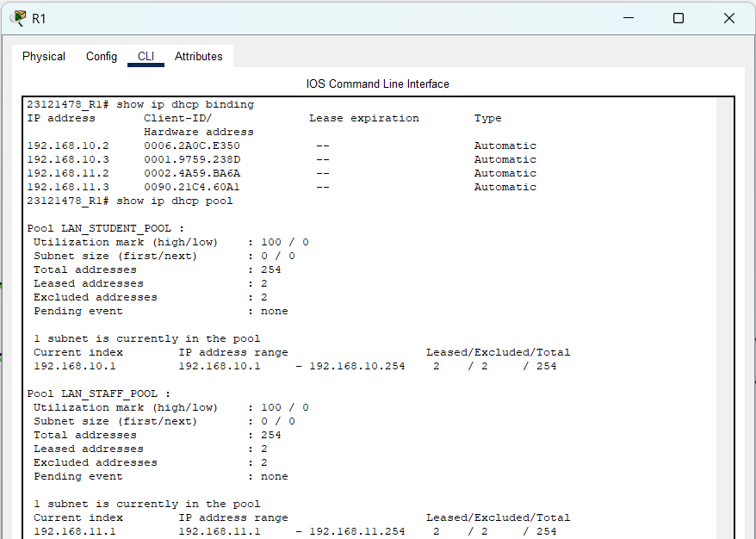

R2 (Router 2) configuration:  
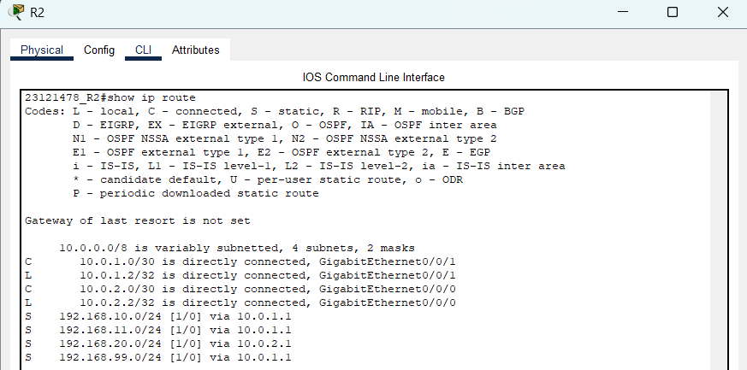

R3 (Router 3) configuration:

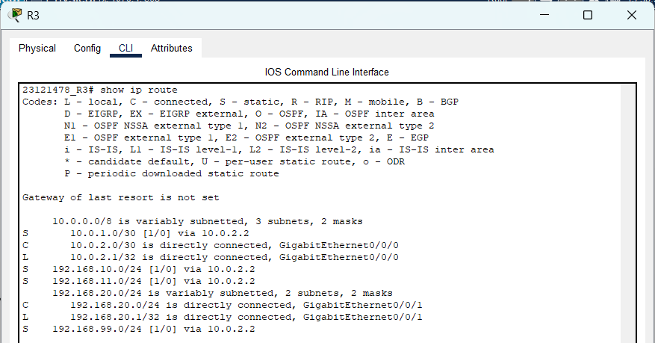

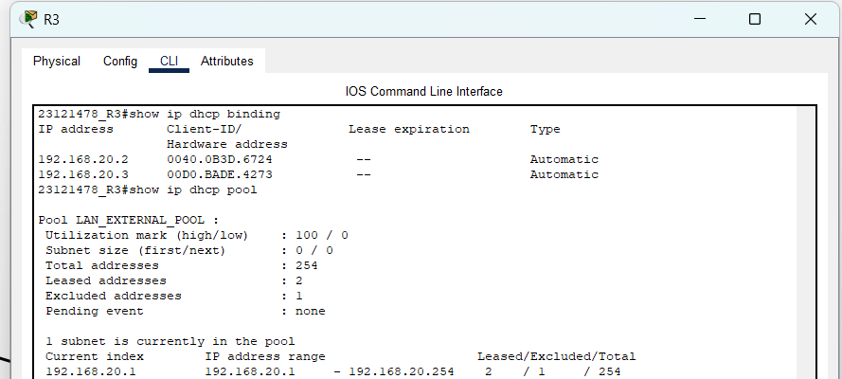

SW1 (Switch 1) configuration:

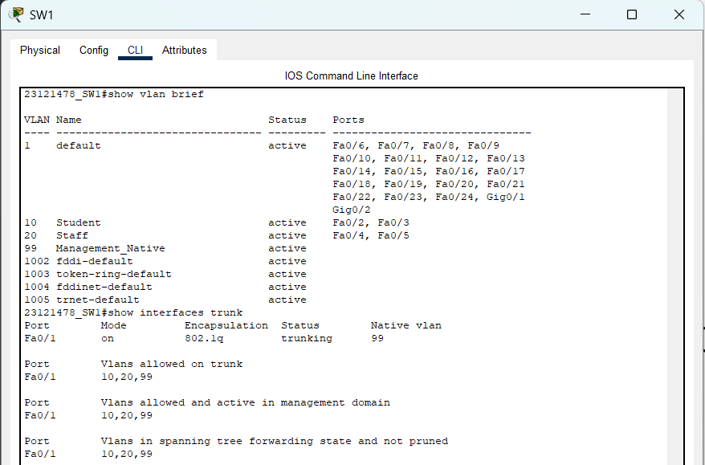

PC0 IP config:

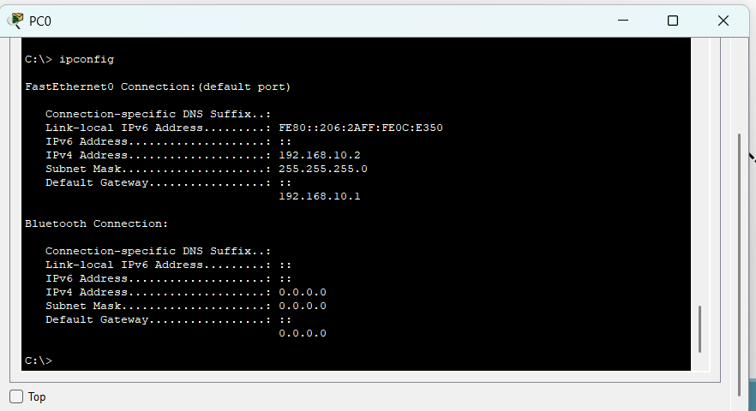

PC1 IP config:  
  
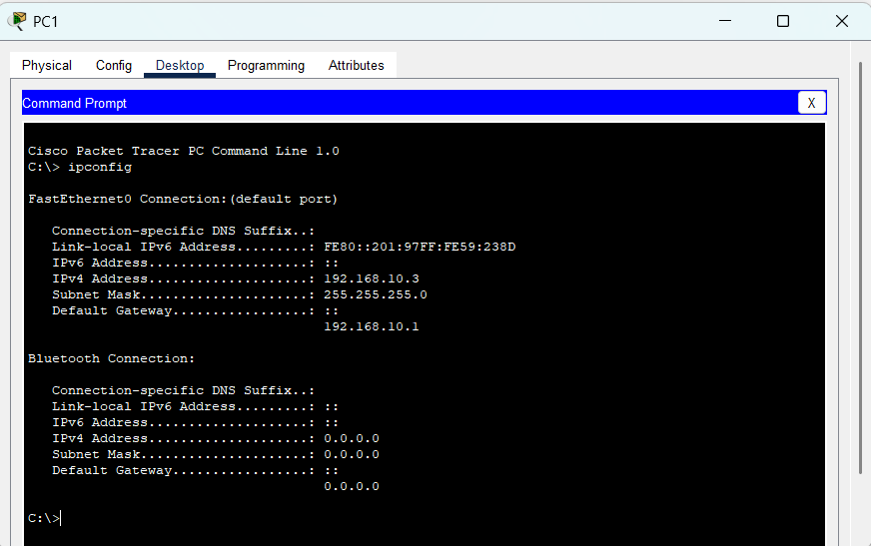

PC2 IP config:  
  
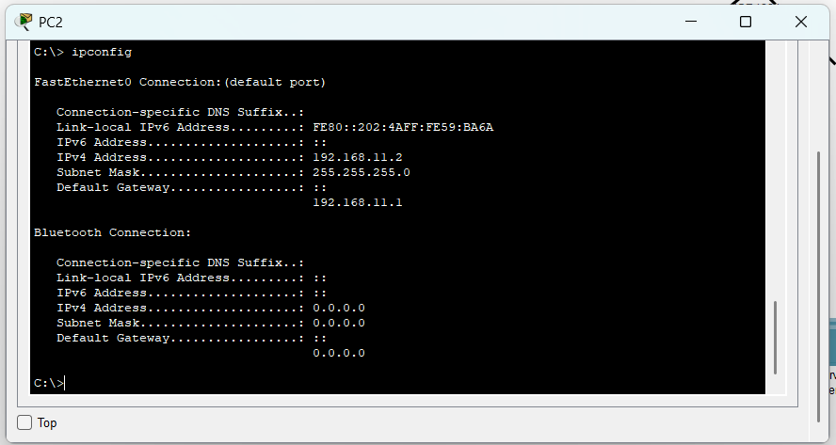

PC3 IP config:  
  
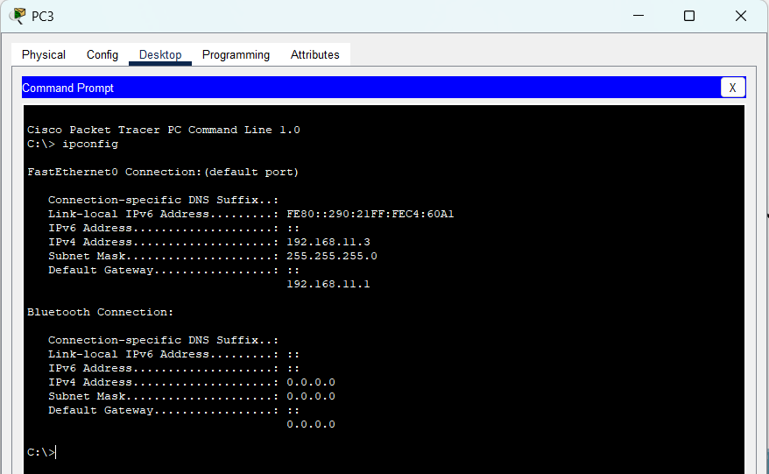

PC4 IP config:  
  
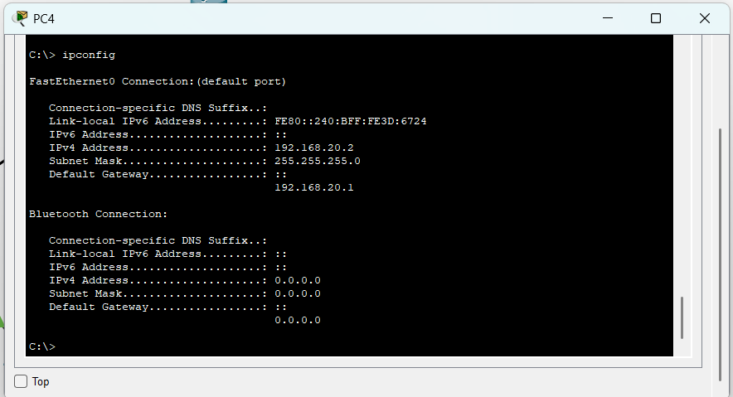

PC5 IP config:  
  
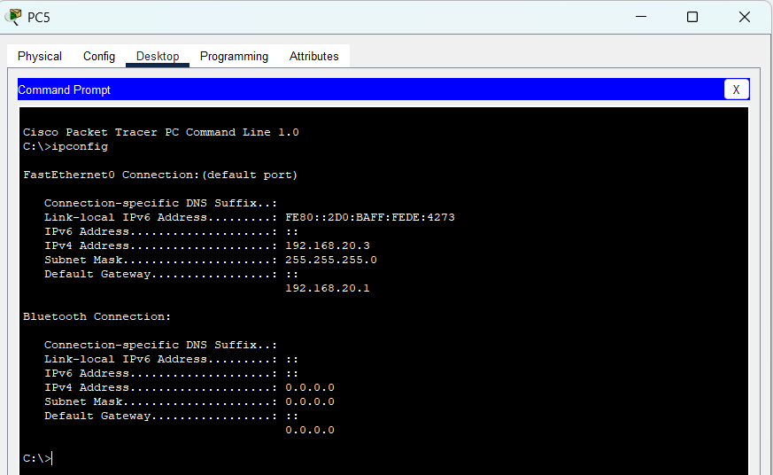

Server0 IP configuration:  
  
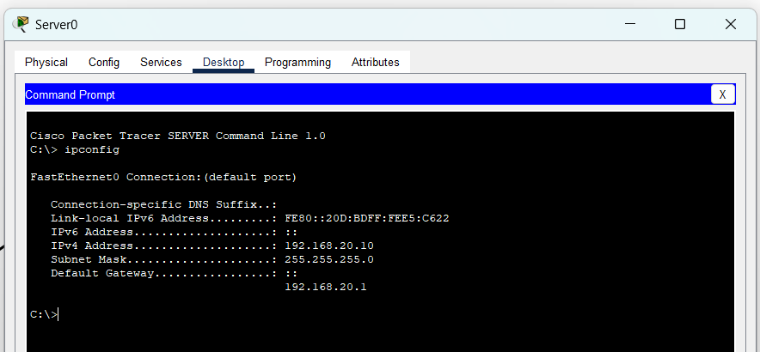

**Ping (Echo request) results:**  
PC0 :  
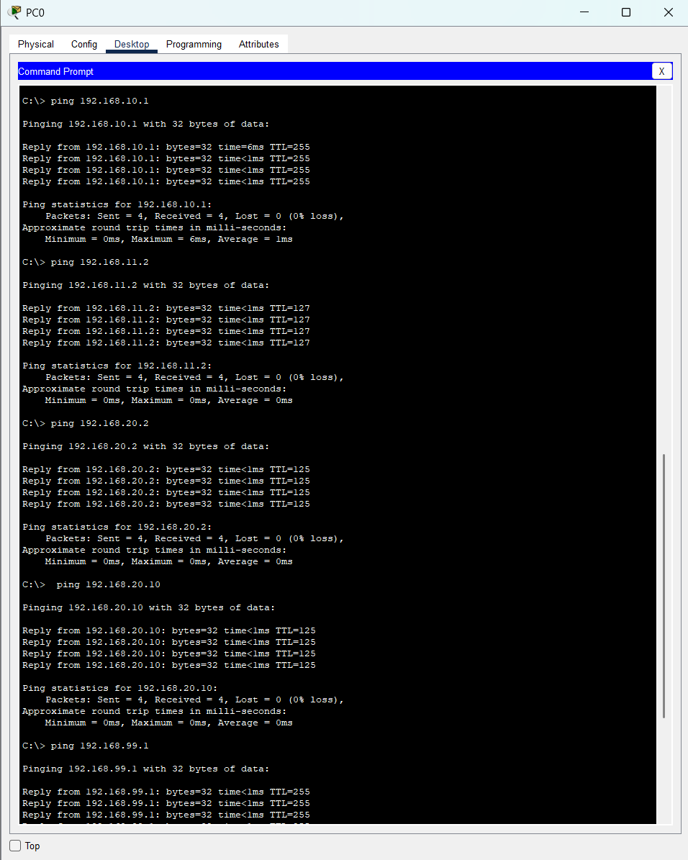

PC2:  
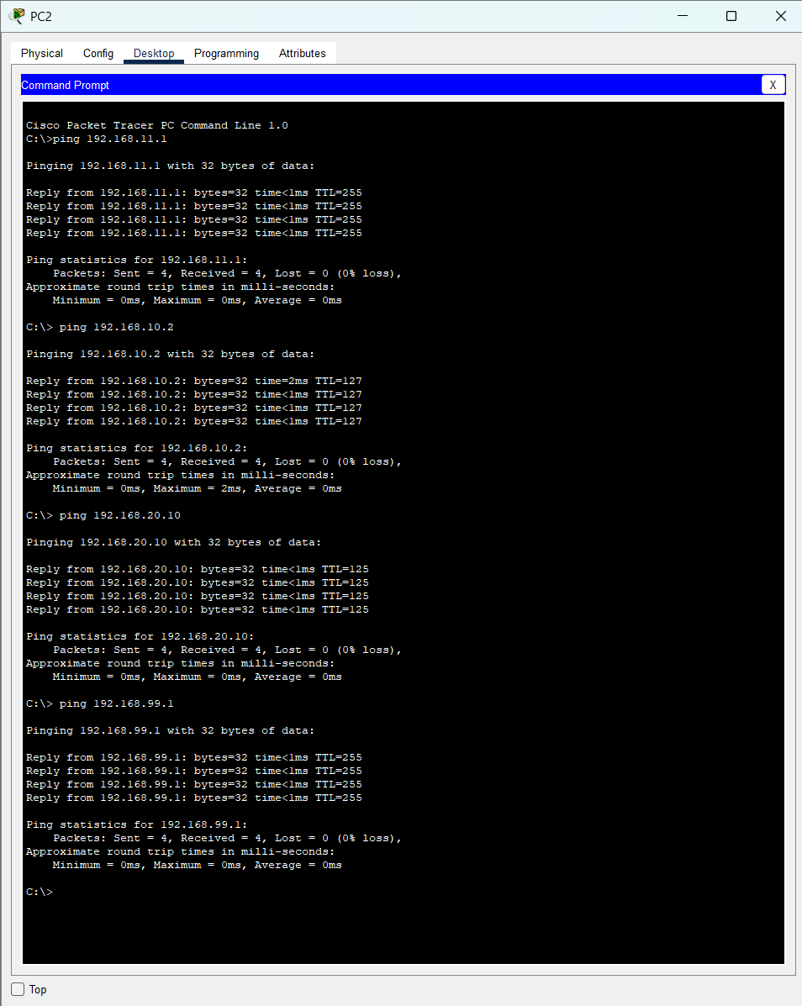

PC4:  


